NAME…………………………………………………….INDEX NO…………………CLASS……………

ADM NO ……..…................. DATE…………......………… SIGN………….….….….…..

231/1
BIOLOGY
PAPER 1
(THEORY)
JULY- 2019
TIME: 2 HOURS

BAHATI FORM FOUR CLUSTER EVALUATION–TERM 11, 2019

Kenya Certificate of Secondary Education (K.C.S.E.)
BIOLOGY
PAPER 1
(THEORY)
TIME: 2 HOURS

INSTRUCTIONS TO CANDIDATES:

1. Write your Name, Index Number, Admission Number and School in the spaces provided above.
2. Sign and write the date of examination in the spaces provided above.
3. Answer all the questions in the spaces provided.
4. Answers must be written in the spaces provided in the question paper.
5. Additional pages must not be inserted.

FOR EXAMINER’S USE ONLY:
Question | Maximum  Score | Candidate’s  Score
1 – 30 | 80

- State the functions of each of the following organelles: (2mks)
- Plasma membrane..............................................................................................................................
......................................................................................................................................................................

- Ribosome.................................................................................................................................................

- (a) State two ways by which leaves of plants are adapted to gaseous exchange. (2mks)

.................................................................................................................................................................................................................................................................................................................................................................................................................................................................................................................................................

b) Name the structure from which the above process occurs. (1mk)
........................................................................................................................................................................

- How do identical and fraternal twins arise?
i) Identical (2mks)
..................................................................................................................................................................................................................................................................................................................................................................................................................................................................................................................................................

ii) Fraternal (1mk)
..................................................................................................................................................................................................................................................................................................................................................................

- State three reasons why it is important for plants to lose water to the atmosphere. (3mks)
..................................................................................................................................................................................................................................................................................................................................................................................................................................................................................................................................................................................................................................................................................................................................
- What is meant by destarching a leaf? (1mk)
.........................................................................................................................................................................................................................................................................................................................................................................................................................................................................................................................................

- State two ways in which sunlight increases the rate of transpiration. (2mks)
..........................................................................................................................................................................................................................................................................................................................................................................................................................................................................................................................................
- List two features of flowers that attract insect pollinators. (2mks)

..........................................................................................................................................................................................................................................................................................................................................................................................................................................................................................................................................
8. State three activities in human digestive system that depend on respiration. (3 mks)

........................................................................................................................................................................................................................................................................................................................................................................................................................................................................................................................................................................................................................................................................................................................
9. In the table below, indicate the deficiency diseases caused by lack of given nutrients in man. (2mks)
Nutrient | Deficiency disease
Iron
Vitamin A

10(a) Give two ways in which red blood cells are adapted to carry out their functions. (2mks)
................................................................................................................................................................................................................................................................................................................................................................................................................................................................................................
(b) Name chemical forms in which carbon IV oxide is transported in the human body. (2mks)
..................................................................................................................................................................................................................................................................................................................................................................................................................................................................................................................................................
11. Name any two divisions of the kingdom plantae. (2mks)
...................................................................................................................................................................................................................................................................................................................................................................................................................................................................................................................................................
12. (a) Name the hormone produced in human body when one takes in a large amount of water. (1mk)
...................................................................................................................................................................................

(b) What disease results from the inadequate production of the hormone in 12(a) above? (1mk)
..............................................................................................................................................................................

13. A cow in a paddock was found to be infected with ticks. State the trophic level occupied by the (2mks)
- i) Cow.......................................................................................................................................

ii) Tick.......................................................................................................................................

- Give one disadvantage of using pesticide to eliminate the ticks. (1mk)
...................................................................................................................................................................................................................................................................................................................................................................
- Write a food chain arising from the above feeding relationship (1 mk)

14. State two roles of water in germinating seeds? (2mks)
.......................................................................................................................................................................................................................................................................................................................................................................................................................................................................................................................................................................................................................................................................................................................
15(a) State two limitations of fossil records as an evidence for organic evolution theory. (2mks)

...........................................................................................................................................................................................................................................................................................................................................................
(b) State an idea that led to the formulation of Lamarck’s theory of evolution. (1mk)

...........................................................................................................................................................................................................................................................................................................................................................
16. Explain what happens to red blood cells placed in distilled water for 20 minutes. (3 mks)

..........................................................................................................................................................................................................................................................................................................................................................
...........................................................................................................................................................................
17(a) Write the base sequence of M RNA that would be coded from the DNA strand shown below. (2mks)
DNA strand
C
A
T
G
A
G
T
RNA strand

(b) How many nitrogenous bases code for a single amino acid? (1mk)

..................................................................................................................................................

18. Why are animal cells put in isotonic solution when performing an experiment? (2mks)
.........................................................................................................................................................................................................................................................................................................................................................................................................................................................................................................................................

19. Study the diagram below
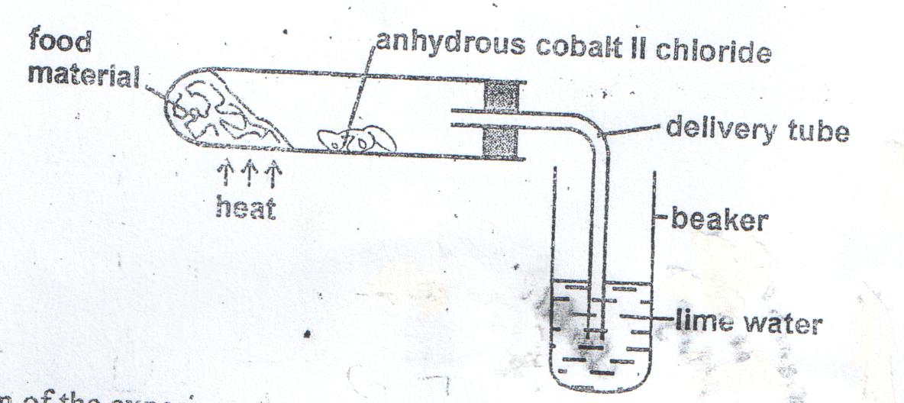
- Suggest the aim of the experiment. (1mk)

..........................................................................................................................................................................................................................................................................................................................................................

- Account for the results observed at the end of the experiment. (2mks)

20. Explain why a camel has a longer nephron than a whale. (3 mks)

21. State role of the following bacteria in the nitrogen cycle. (3mks)
- Nitrosomonas...............................................................................................................................

- Nitrobacter...................................................................................................................................

- Azotobacter.................................................................................................................................

22. Explain the importance of each of the following during digestion in man.
- Teeth................................................................................................................................. (1mk)

- Saliva ................................................................................................................................(1mk)

23(a) Distinguish between prokaryotic and eukaryotic cells. (2mks)
...............................................................................................................................................................................................................................................................................................................................................................................................................................................................................................................................................................................................................................................................................................

b) Name one kingdom with:
- Prokaryotic cells ........................................................................................................(1mk)

- Eukaryotic cells..........................................................................................................(1mk)

24. What would blood gain on passing through each of the following organs:
- The lungs....................................................................................................................(1mk)

- Active muscles...........................................................................................................(1mk)

25. How do sunken stomata lower the rate of transpiration? (2 mks)

........................................................................................................................................................................................................................................................................................................................................................................................................................................................................................................................

26. State two adaptations of fruits dispersed by wind. (2mks)
............................................................................................................................................................................................................................................................................................................................................................
..............................................................................................................................................................................

27(a) Describe two ways how white blood cells fight against infection. (2mks)
.............................................................................................................................................................................................................................................................................................................................................................................................................................................................................................................................................................................................................................................................................................
(b) State the function of blood platelets (1mk)

...................................................................................................................................................................................

28. Calculate the diameter of the cells in micro-metre( µm) given that the diameter of the field of view is 3mm and that they are 10 cells across the field of view, the total magnification was x100. (3mks)

29. (a) Apart from AIDs, name one diseases of the reproductive system in man that is caused by viruses. (1mk)
................................................................................................................................................................................................................................................................................................................................................

(b) State one way by which HIV/AIDs is transmitted from mother to child. (1mk)

......................................................................................................................................................................................................................................................................................................................
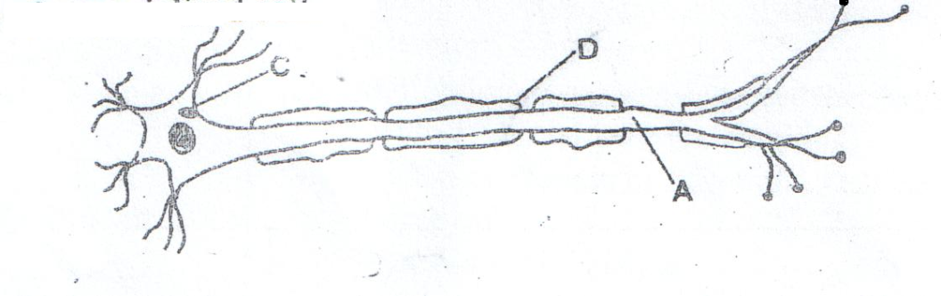
30 (a). Below is a diagram of a specialized cell:

- Name parts (2mks)
A ......................................................................................................................................

D......................................................................................................................................

- What is the role of part D? (1mk)
..................................................................................................................................................................................................................................................................................................................................................................
b. State two roles of progesterone. (3mks)
............................................................................................................................................................................................................................................................................................................................................................ ...........................................................................................................................................................................................................................................................................................................................................................
End

BAHATI CLUSTER EXAMINATION
BIOLOGY PAPER 1 FORM FOUR MARKING SCHEME
JULY 2019
- (a) Control movement of materials in and out of the cell;
Enclose the cell contents
(b) Site of protein synthesis;

- Presence of stomata to allow passage of gases;
- Presence of intercellular spaces/air passages to allow free circulation of air;
- Thin to allow easy diffusion of gases;
- Flattened shape to offer large surface area of air to reach cells;
- Moist inner surface of cells to allow easy diffusion of gases;
- Exposure to air to allow easy diffusion of gases;
Mark only first two.

(b) Stomata

- i) Identical – a fertilized ovum divided into two; and develops into two separate embryos;
ii) Fraternal – two different ova are fertilized;(by different sperms)

4 -Cools the plant cells
- Provide mechanism through which mineral salts and water are transported in
plants cell
- Removal of excess water from the plants.
- Maintain turgor of cells

5. Process by which the leaf is made devoid of starch; (by keeping it in dark (about 48 hours); so that all starch present is used up.)

6. -By increasing internal leaf temperature thus high rate of evaporation of water from the leaf;
-By increasing the size of stomata opening aperture hence large surface area for water loss;

7. -brightly colored petals;
-Sweet scented
- nectar from nectaries (nectaries glands);
They Mark only first two

8. - Absorption of digested food materials
- Secretion of digested enzymes/hormones/mucus
- Contraction and relaxation of smooth muscles of alimentary canal to
bring about peristalsis
- Chewing/mastication(movement of jaw muscles)

9. iron-anaemia, Vit A-Night blindness/poor night vision

10(a) -lack of nucleus increasing the surface area of haemoglobin package;
-Small in size to squeeze in the small capillaries;
-Numerous/many to increase surface for efficient transport of oxygen;
-Biconcave to increase the surface area for oxygen to diffuse in;
Mark only first two.

(b) – Weak carbonic acid;
- Hydrogen carbonate;
- Carbaminohaemoglobin
11. – Bryophyta;
- Spermatophyta/spermaphyta
- Pteridophyta;

12 (a) Antidiuretic hormone (ADH)/ Vasopresin;
(b) Diabetes insipidus; rej. Water diabetes

13(a) (i) Primary consumer;
(ii) Secondary consumer;

(b) -Pollutes environment;
- kill non-targeted organisms
Mark first one
c)grass/plants cow tick

14.– Hydrolysis of stored food;
- Acts as a solvent for hydrolysed foods;
- Medium of transport;
- Activation of enzymes for hydrolysed foods;
- Medium for enzymatic reactions;
- Soften seed coat to allow plumule and radical to come out;
Marked only first two

15(a) Desctruction of fossils by geological activities;
- Distortion of information due to sedimentation;
- Missing record/linkss;
only first two

(b) – the theory of need;
- the theory of use and disuse;
- acquired traits can be inherited;
16. Red blood cells draw in water by osmosis. They swell/enlarge and the cell membrane
Bursts ( by a process called haemolysis)

17 (a)
G
U
A
C
U
C
A
RNA strand

(b) Three;
18. To maintain osmotic pressure of the cells in the tissue; to as to obtain accurate results.
To avoid the cell gaining or loosing water;which can inaccurate resu;lts
19(a) - To investigate products of (aerobic) respiration
To investigate the gas produced during respiration
Reject anaerobic respiration
(b) – Lime water form white precipitate; to show that carbon IV oxide is produced;
- blue cobalt II chloride turns pink; due to the presence of water produced when food burns
Mark the two points independently
20. A camel is a desert animal, a larger nephron increases the surface area; for
reabsorption of water; to conserve it; while a whale is an aquatic animals (hence does not need to conserve water)

21.(a) Converts Ammonia to nitrites;
(b) Converts nitrites to nitrates;
(c) Fix nitrogen into ammonia which is then converted to nitrates;

22. (a) Cut /chew/crush/grind food to increase surface area for digestion;/easy swallowing.
(b) Contain water which is a medium for chemical reactions; / acts as a solvent.
- Contain salivary amylase/ptyalin which digests starch to maltose.
-contain mucus/mucin to lubricate food material
Any first one.

23(a) Prokaryotic – nuclear materials not membrane bound (naked;)
Eukaryotic – nuclear bound by membrane; NB-Use sentence connector i.e. use of while for student to score)

(b) (i) Monera;
(ii) Protoctista/plantae/animalia/fungi;

24 (i) The lungs – oxygen;
(ii) Active muscles carbon IV oxide;/ lactic acid.

25– Water vapour accumulates in the pits/depression; lowering the water vapour
concentration gradient thus lowering the rate of water loss from the leaves.

26.– Are small and light to be carried easily by wind;
-Develop wing-like extensions to increase surface area for increased buoyancy in the air;
-Have hair like structures or floss to increase buoyancy in the air; (only first two).

27(a) By engulfing and digesting pathogens;
-By secretion of antibodies; which destroy pathogens and their products.

(b) blood clotting to stop further bleeding
28. Size of cell = diameter of field of new =
No of cells

=

= 300µm.

Actual size = == 3µm.

29 (a) Hepatitis B;
Herpes;

(b) – Breast feeding;
- Through placenta;
30a (i) A – Axon;
D – myelin sheath;

(ii) insulate the axon;

b) – growth of mammary glands
- Inhibit FSH;
- Inhibit prolactin release
- Inhibits contraction of myometrium;
Only first two

NAME ………………………………………………………… INDEX NO.……………………
SIGNATURE ……………………………………… DATE…………………………………………

231/2
BIOLOGY
(THEORY)

PAPER 2

TIME: 2 HOURS

BAHATI FORM FOUR CLUSTER EVALUATION TERM TWO 2019

INSTRUCTIONS TO CANDIDATES
- Write your name, school and index number in the spaces provided above.
- Write the date of examination and sign in the spaces provided above.
- Answer ALL the questions in section A by filling in the spaces provided.
- In section B, answer question 6 (compulsory question) and any other one question from the remaining two questions. (i.e. 7 or 8)
- Candidates may be penalized for false information and even wrong spellings of technical terms.
- This paper consists of 10 printed pages.
- Candidates should check to ensure that all pages are printed as indicated and no questions are missing.

FOR OFFICIAL USE ONLY
 | Questions | Maximum score | Candidate’s score
Section A | 1 | 8
Section A | 2 | 8
Section A | 3 | 8
Section A | 4 | 8
Section A | 5 | 8
Section B | 6 | 20
Section B | 7 | 20
Section B | 8 | 20
 | Total Score | 80

1.A specimen of Drosophila has red eye and when crossed with a purple mutant all the F1 had red eyes.The offspring’s were mated among themselves and the following proportions of flies were produced; 201 gad red eyes and 67 had purple eyes.Using R to represent the dominant gene and r to represents the recessive gene,answer the following questions.
i)By the help of diagrams shows how the ratio of 201:67 was arrived at ,in the F2generation. (5mks)

ii)Draw diagrams to show the genetic details of a cross between the heterozygous red eyed and a purple eyed individual form F2. (3mks)

2.The diagram below shows the relationship between blood supplies of the embryo, placenta and the uterus.Use it to answer the question that follow.
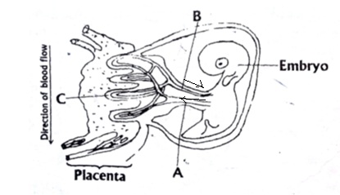

- Name the part labeled A and C. (2mks)

- State any two functions of placenta in mammals. (2mks)

- .(i)What kind of flow does maternal and foetal capillaries exhibit at the placenta. (1mk)

(ii)Why is this kind of flow(c) (i) have an advantage. (1mk)

- If the maternal and foetal blood circulatory system were to be directly connected at the placenta suggest what may happen. (1mk)

- In lactating mammals if the pituitarygland isremoved, explain what happens. (1mk)

3.A student was given four test tubes A, B, C and D, each containing a different mixture among the following:
- Starch +amylase + maltase+water
- Starch +Pepsin +Water
- Starch +Glucose +Water
- Cellulose +amylase+trypsin+Water
She placed the test tubes in an incubator at 30⁰C until all possible reactions had taken place.She then took samples from each test tube and tested them separately for starch,reducing sugar and protein.The results obtained are given in the following table.

Tube | Starch | Reducing | Protein
A | Present | Present | Absent
B | Absent | Absent | Present
C | Present | Absent | Present
D | Absent | Present | Present

a) Name a reagent used to test for reducing sugar and state the appearance of a positive result. (2mks)

b) Identify the contents of each of the test tube A,B,C and D according to the results obtained. (4mks)

c) State the role of enzyme in respiration. (2mks)

4. The graph below shows the effect of injecting one unit of insulin into aperson .The concentration of glucose in the blood is measured at regular intervals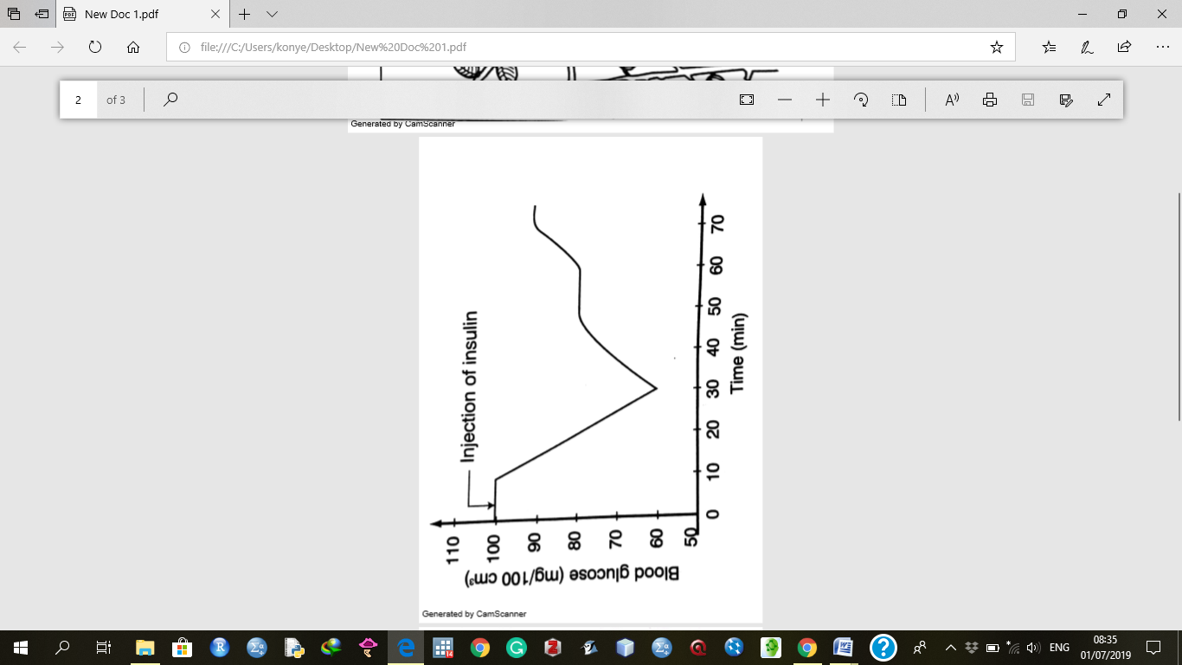
a) Why is insulin injected into blood stream directly instead of being taken orally. (2mks)

b) Explain the fall in blood glucose level. (2mks)

c) Name the mechanism that led to the increase in blood glucose level when it had been falling. (1mk)

d) Name the hormone responsible for the conversion of glycogen to glucose. (1mk)

e) State the effects of each of the following in human beings.
i)Too much glucose in the blood. (1mk)

ii) Very little glucose in the blood. (1mk)

5. The diagram below shows a stem of a passion fruit twining around a post.
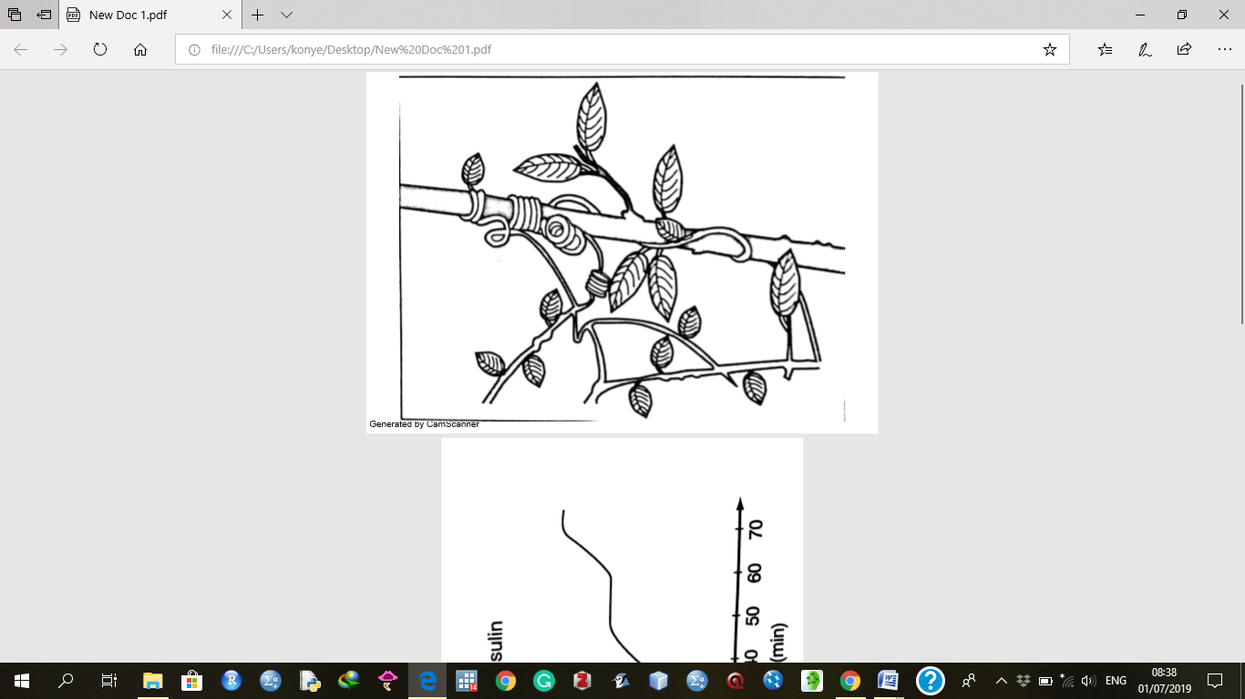

a)What is the name given to the type of growth movement shown above? (1mk)

b) What is the biological importance of this growth? (1mk)

c.i)Account for the twining growth pattern. (3mks)

ii) Name three other types of growth responses exhibited by plants. (3mks)

SECTION B(40 MARKS)
Answer question 6 and either question 7 or 8
6.The formation of acid rain is a serious environmental concern.Sulphuric acid is present in acid rain and has adverse effects on both plants and animals.
a)Name two other acids (other than sulphuric acid)that can be found in acid rain. (2mks)

b)An experiment was carried out to investigate the effects of dilute sulphuric acid on the growth of plant seedlings.Batches of seedlings were grown in glass dishes on filter paper to which dilute sulphuric acid was added.The dishes were then incubated.The root and shoot lengths were measured after 65 hours.The results obtained are as shown in the table below.
Sulphuric acid  Concentration (mol/dm⁻³) | Mean root  Length(mm) | Mean shoot  Length(mm)
0 | 55.5 | 25.2
1x10⁻³ | 63.4 | 18.4
3x10⁻³ | 6.5 | 9.5
4x10⁻³ | 2.0 | 4.6
6x10⁻³ | 1.8 | 0.8
7x10⁻³ | 1.5 | 0.5
8x10⁻³ | 1.3 | 0.3
9x10⁻³ | 1.3 | 0.0
10x10⁻³ | 1.0 | 0.0


Plot a graph of the mean root length and the mean shoot length against the sulphuric acid concentration on the same grid. (7mks)
c) Describe the relationship between the concentration of sulphuric acid and the:
i)Growth of the shoots. (2mks)

ii)Growth of the roots. (2mks)

d) Estimate the mean root and mean shoot lengths when the concentration of sulphuric acid is 5x10⁻³. (2mks)

e)State two other effects of acid rain. (2mks)

f) State three ways of preventing acid rain. (3mks)

SECTION C(Answer one question only)
7.(a) Describe the following terms:
(i) Secretion
(ii) Excretion
(iii) Egestion (3 mks)
b)Explain how the mammalian kidney is adapted to its functions. ( 17 mks)
8.Explain the role of hormones in the growth and development of plants. (20mks)

MARKING SCHEME
1.A specimen of Drosophila has red eye and when crossed with a purple mutant all the F1 had red eyes.Theoffsprings were mated amony themselves and the following proportions of flies were produced; 201 gad red eyes and 67 had purple eyes.Using R to represent the dominant gene and r to represents the recessive gene,answer the following questions.
i)By the help of diagrams shows how the ratio of 201:67 was arrived at ,in the F2generation. (5mks)
ii)Draw diagrams to show the genetic details of a cross between the heterozygous red eyed and a purple eyed individual form F2.
` (3mks)
2.The diagram below shows the relationship between blood supplies of the embryo ,placenta and the uterus. Use it to answer the question that follow.
a)Name the part labeled A and C. (2mks)
A-Umbilical artery
C-Chorionic villus
b) State ay two functions of placenta in mammals. (2mks)
-secretes hormones oestrogen and progesterone which maintains pregnancy
-Facilitates transfer of nutrients and oxygen from mother to embryo
-Facilitates transfer of metabolic waste from embryo to mother
-Facilitates transfer of antibodies
c.(i)What kind of flow does maternal and foetal capillaries exhibit at the placenta. (1mk)
-Counter current flow
(ii)Why is this kind of flow(c) (i)have an advantage. (1mk)
-Creates a steep concentration gradient for efficient exchange of materials
d)If the maternal and foetal blood circulatory system were to be directly connected at the placenta suggest what may happen. (1mk)
-Blood capillaries of foetus would burst due to high pressure from the maternal system.Toxic materials from, the mother might leak into foetus.
e)In lactating mammals if the pitutary glands is removed ,explain what happens. (1mk)
3.A student was given four test tubes A,B,C and D, each containing a different mixture among the following :
i)Starch +amylase + maltase+ water
ii)Starch +Pepsin +Water
iii)Starch +Glucose +Water
iv)Cellulose +amylase+ typsin+ Water
she placed the test tubes in an incubator at 30⁰C until all possible reactions had taken place. She then took samples from each test tube and tested them separately for starch, reducing sugar and protein. The results obtained are given in the following table.
Tube | Starch | Reducing | Protein
A | Present | Present | Absent
B | Absent | Absent | Present
C | Present | Absent | Present
D | Absent | Present | Present

a)Name a reagent used to test for reducing sugar and state the appearance of a positive result. (2mks)
-Reagent –Benedict’s solution
-Result-An orange precipitate is formed
b)Identify the contents of each of the test tube A,B,C and D according to the results obtained (4mks)
Tube | Mixture
A | (iii)
B | (iv)
C | (ii)
D | (i)

c)State the role of enzyme in respiration. (2mks)
-They are biological catalysts. They control chemical reaction during respiration, which takes place in many small steps.
4.The graph below shows the effect of injecting one unit of insulin into a person .The concentration of glucose in the blood is measured at regular intervals.
a)Insulin being a protein it will be digested by protein digestive enzymes

b)Explain the fall in blood glucose level. (2mks)
-The blood glucose level fell because insulin stimulated the liver cells to convert some glucose into glycogen. Some glucose was oxidized to provide energy.
c)Name the mechanism that led to the increase in blood glucose level when it had been falling. (1mk)
-Negative feedback mechanism
d)Name the hormone responsible for the conversion of glycogen to glucose. (1mk)
-Glucagon hormone
e)State the effects of each of the following in human beings.
i)Too much glucose in the blood. (1mk)
-Overproduction of energy by tissues which can burn them.
ii)Very little glucose in the blood. (1mk)
-Reduced energy by tissues which results to reduced cellular activities
5.The diagram below shows a stem of a passion fruit twining around post.
a)What is the name given to the type of growth movement shown above? (1mk)
-Thigmotrophism/Haptotropism
b)What is the biological importance of this growth? (1mk)
-It provides mechanical support to plant lacking woody stems.
c.i)Account for the twining growth pattern. (3mks)
-There is low auxin concentration on the side which comes into contact with the post. There is a higher concentration of auxins on the side away from the contact surface.Auxinscause more growth on the side away from the contact surface.The stem then twines around the support plant.
ii)Name three other types of growth responses exhibited by plants. (3mks)
-Phototropism
-Chemotropism
-Geotropism
-Hydrotropism
SECTION B(40 MARKS)
Answer question 6 and either question 7 or 8
6.The formation of acid rain is a serious environmental concern. Sulphuric acid is present in acid rain and has adverse effects on both plants and animals.
a)Name two other acids (other than sulphuric acid)that can be found in acid rain. (2mks)
-Nitric acid
-Carbonic acid
b)An experiment was carried out to investigate the effects of dilute sulphuric acid on the growth of plant seedlings. Batches of seedlings were grown in glass dishes on filter paper to which dilute sulphuric acid was added. The dishes were then incubated. The root and shoot lengths were measured after 65 hours. The results obtained are as shown in the table below.
Sulphuric acid  Concentration (mol/dm⁻³) | Mean root  Length(mm) | Mean shoot  Length(mm)
0 | 55.5 | 25.2
1x10⁻³ | 63.4 | 18.4
3x10⁻³ | 6.5 | 9.5
4x10⁻³ | 2.0 | 4.6
6x10⁻³ | 1.8 | 0.8
7x10⁻³ | 1.5 | 0.5
8x10⁻³ | 1.3 | 0.3
9x10⁻³ | 1.3 | 0.0
10x10⁻³ | 1.0 | 0.0
Plot a graph of the mean root length and the mean shoot length against the sulphuric acid concentration on the same grid. (7mks)
c)Describe the relationship between the concentration of sulphuric acid and the:
i)Growth of the shoots. (2mks)
-As the acid concentration increases,the growth of the shoot decreases due to the low pH which is toxic to the cells.
ii)Growth of the roots. (2mks)
-The length of the root increases, slightly at the beginning ,but as the acid concentration increases the growth decreases .Low pH is not suitable for the growth of roots.
d)Estimate the mean root and mean shoot lengths when the concentration of sulphuric acid is 5x10⁻³. (2mks)
-The mean shoot length 2.0mm0.1
-The mean root length 2.0mm0.1
e)State two other effects of acid rain. (2mks)
-It kills organisms in water and soil
-It corrodes walls and roofs of buildings
-It causes leaching of aluminium from soils
f)State three ways of preventing acid rain. (3mks)
-Use substances that extract sulphur from sulphur-containing fuel
-Fit chimneys with scrubbers that dissolves gases such as sulphurdioxide and nitrogen dioxide.
-Increases use of electricity instead of fossil fuels
-Fit automobiles with filters and catalytic converters in their exhaust pipes to reduce emission of sulphur oxides.
8.(a) Describe the following terms:
(i) Secretion
Secretion is discharge of useful substances such as hormone and enzymes.
(ii) Excretion
Excretion is the elimination of waste products of metabolism
(iii) Egestion (3 mks)
Egestion is the removal of indigestible and undigested materials from the alimentary anal.
b)Explain how the mammalian kidney is adapted to its functions. ( 17mks)
(b) Has renal artery to supply blood rich in metabolic wastes.
-Has renal vein that drains purified blood from the kidney
-Renal artery branches into arterioles that serve individual nephrons
-Efferent arteriole is narrower than the afferent arteriole to create high pressure required for ultra filtration.
-Glomerular capillaries are very narrow to create high pressure to enhance ultra filtration.
-Has a capsule barrier that selectively allows some substance to pass through.
-Has convoluted tubule that is highly coiled to slow down rate of flow of filtrate to allow more time for re-absorption.
-Has a proximal convoluted tube having micro villa which increases the surface area for reabsorption.
-Has gromerulous with cell lining having numerous mitochondria which provides the necessary energy in form of ATP

8.Explain the role of hormones in the growth and development of plants. (20mks)
Auxins
-Auxins promote cell division
-They influence tropic responses.
-They stimulate the formation of the abscission layer/leaf fall
-Auxins promote parthenocarpy.
-Auxins promote cell differentiation in vascular tissues.
-They also cause apical dominance
-They stimulate the growth of adventitious roots
-Auxins together with cytokines induce formation of callus tissue for healing of wounds.
Gibberellins
-Gibberellins stimulate cell division and elongation in dwarf varieties.
-They also stimulate parthenocarpy
-They inhibit growth of adventitious roots
-Gibberellins break seed dormancy by activating enzymes during seed germination.
-Gibberellins also retard leaf abscission

Cytokinins
-Cytokinins break seed dormancy in some plants.
-They stimulate flowering in some plants.
-Cytokinins promote cell division in the presence of IAA.
-They stimulate formation of roots.
-They encourage leaf senescence when in low concentrations.
-In high concentration they stimulate leaf growth/expansion.
Ethylene
-Ethylene stimulates development of lateral buds.
-It stimulates ripening of fruits.
-It induces stem thickening.
-It inhibits stem elongation.
-It causes abscission of leaves and fruits.
-It promotes flowering in some plants.
Abscisicacid(ABA)
-Abscisic acid causes stomatal closure.
-It inhibits seed germination.
-It causes leaf and fruit fall.
-It inhibits stem elongation and general growth.
-It also causes seed dormancy.

NAME: ………………………………………….……… INDEX NO……………………CLASS…………
ADM NO: .........................................DATE…………………………. SIGN………………………………

231/3
BIOLOGY
PAPER 3
PRACTICAL
TIME: 1 ¾ HOURS

BAHATI FORM FOUR CLUSTER EVALUATION-
TERM II 2019
Kenya Certificate of Secondary Education( K.C.S.E.)

Instructions to candidate
- Answer ALL questions
- You are required to spend the first 15 min of 1³/₄ hours allowed for this paper reading the whole paper before carefully before commencing your work.
- Answer must be written in the spaces provided in the question paper
- Don’t insert additional page /paper

FOR EXAMINER USE ONLY
QUESTIONS | MAXIMUM SCORE | CANDIDATE SCORE
1 | 14
2 | 13
3 | 13
TOTAL | 40

- You are provided with specimen A and B
- Name the sub-division to which the specimen belong (1mk)
…………………………………………………………………………………………………...
- Name the class to which the specimens belong (2mks)
A…………………………………………..
B…………………………………………..
- State three observable differences between the leaves of specimen A and B (3mks)
Leaves A | Leaves B
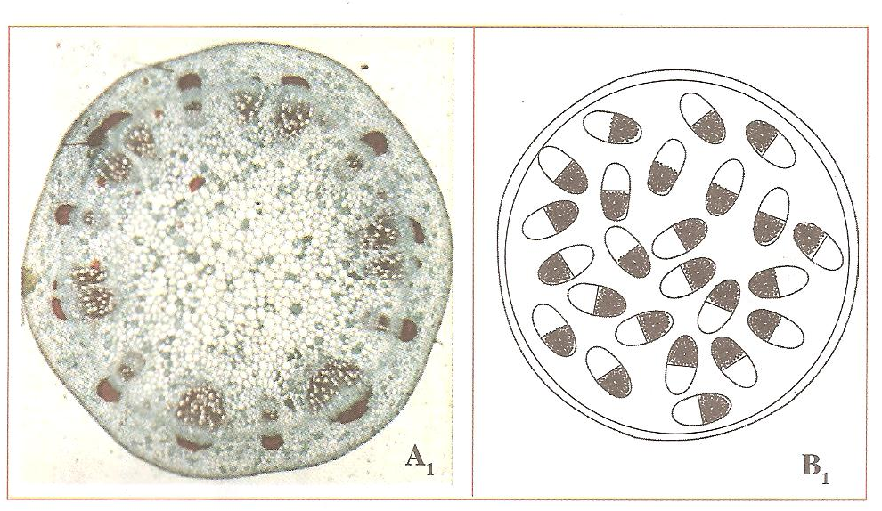
- The diagram below show the cross-sections of stems obtained from specimens A and B

- Match the stem cross-sections with the specimens (2mks)
……………………………………………………………………………………………………………………………………………………………………………………………….
- Outline three differences between the two stems (3mks)
Specimen A₁ | Specimen B₁

- Suggest the agent of pollination of the flowers of specimen A (1mk)
………………………………………………………………………………………………..
Give reason for your answer (1mk)
…………………………………………………………………………………………………

- You are provided with photographs of specimens labeled K (gills) and L (lungs). Examine them and answer the questions that follow.
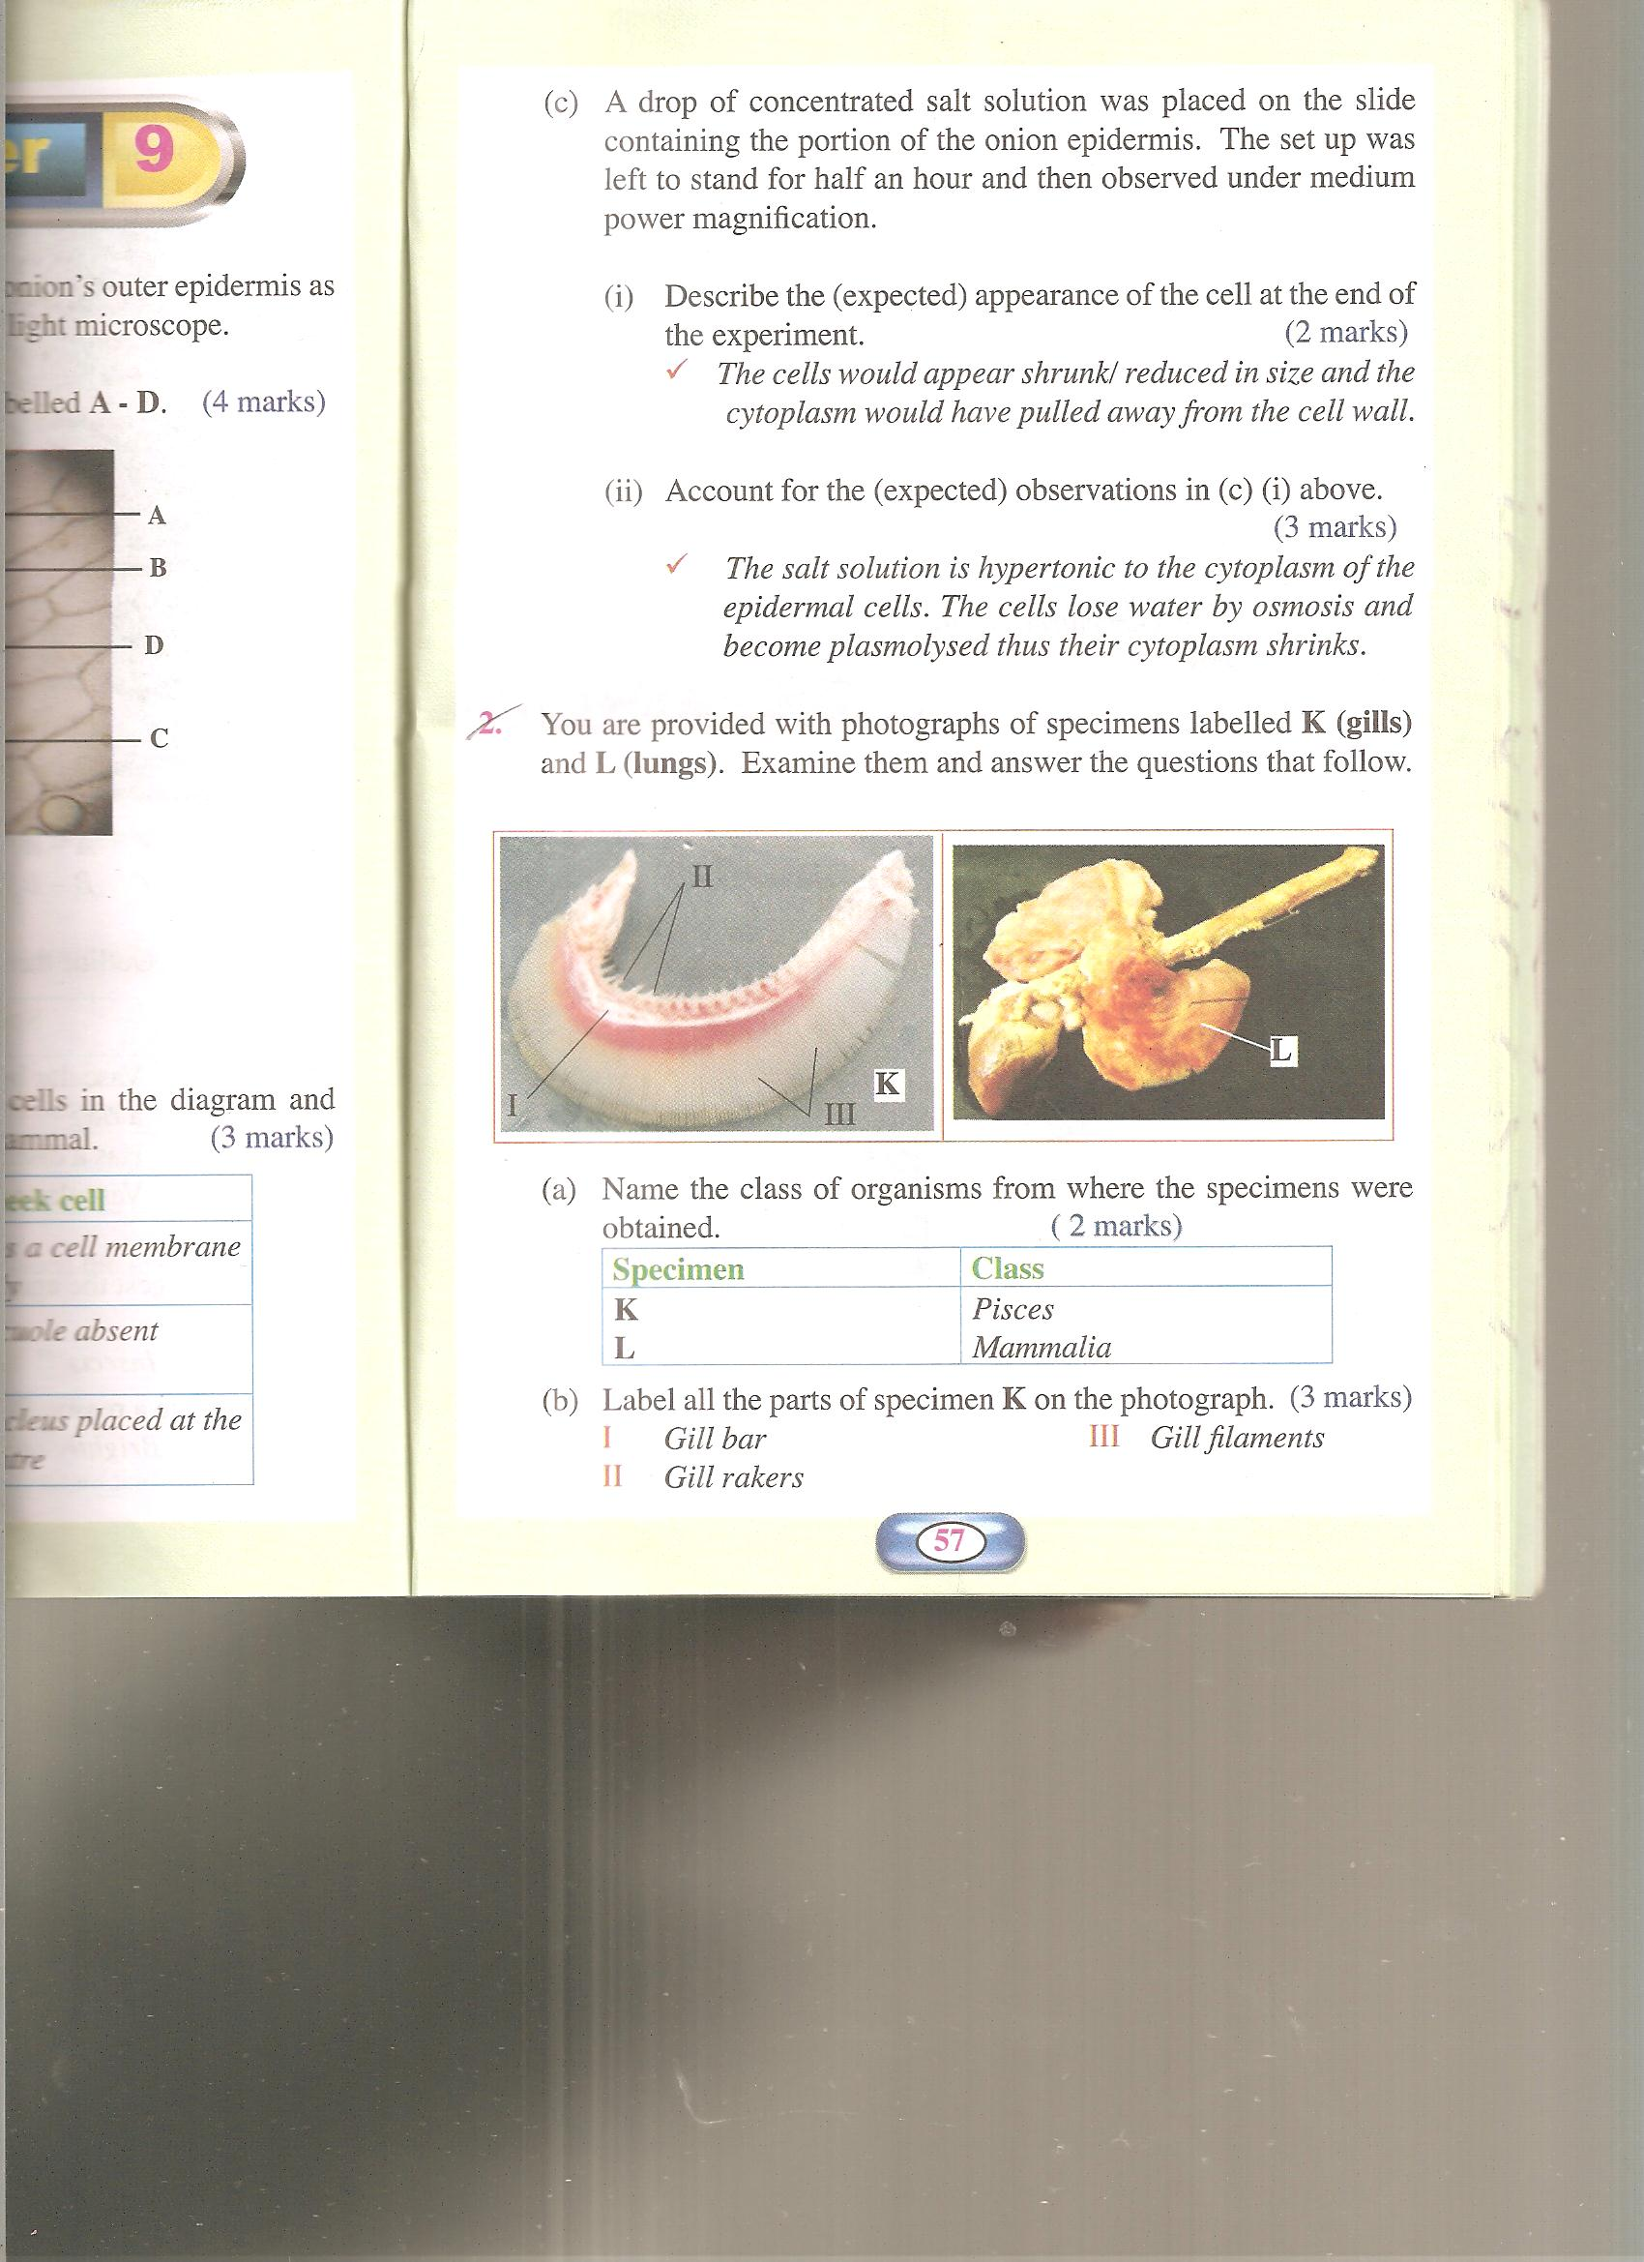

- Name the class of organisms from where the specimens were obtained (2mks)
Specimen | Class
K
L

- Label all the parts of specimen K on the photograph (3mks)
I…………………………
II………………………..
III………………………
- State the functions of each of the parts you have labeled in (b) above (3mks)
………………………………………………………………………………………………………………………………………………………………………………………………………………………………………………………………………………………………………………………………………………………………………………………………………………………………
- State three ways in which the part labeled L is adapted to its functions (6mks)
………………………………………………………………………………………………………………………………………………………………………………………………………………………………………………………………………………………………………………………………………………………………………………………………………………………………………………………………………………………………………………………………………………………………………………………………………………………………………………………………………………………………………………………………………………………

- State the functional relationship between specimens K and L (1mk)
………………………………………………………………………………………………………………………………………………………………………………………………………………
- You are provided with:
- 1ml Olive oil
- K₁ (Concentrated sodium hydrogen carbonate solution)
- K₂
- Irish potato
- Test tube
- Iodine solution
Label two test tubes X and Y. Into each test tube; put 2cm³ of water and 8 drops of Olive oil. To the test tube labeled X, add 8 drops of Liquid K₁. Shake both test tubes and allow the contents to stand for 2 minutes
- (i) Record your observation in: (2mks)
Test tube X
………………………………………………………………………………………………………………………………………………………………………………………………………………………………………………………………………………………………………
Test tube Y
………………………………………………………………………………………………………………………………………………………………………………………………………………………………………………………………………………………………………
(ii) Name the process that has taken place in test tube X (1mk)
…………………………………………………………………………………………………
(iii) Stage the significance of the process named in (a) (i) above in digestion (1mk)
………………………………………………………………………………………………….
(iv) Name the:
- Digestive juice in human beings that has the same effect on oil as liquid K₁ (1mk)
………………………………………………………………………………………
- Region of alimentary canal where the juice is secreted (1mk)
…………………………………………………………………………………………
- Label two test tubes E and F. place 2cm³ of liquid K₂ into each. Add a drop of iodine solution into each test tube
- Record your observations (1mk)
………………………………………………………………………………………….

- Suggest the identity of liquid K₂ (1mks)
…………………………………………………………………………………………
- Cut out a cube whose sides are 1cm from the irish potato provided. Crush the cube to obtain a paste and place the paste in the test tube labeled E. Leave the set up for at least 30minutes
Record your observations (2mks)
……………………………………………………………………………………………….
………………………………………………………………………………………………
……………………………………………………………………………………………….
- Account for the results in (b) (iii) above (2mks)
……………………………………………………………………………………………………………………………………………………………………………………………………………………………………………………………………………………………………………………………………………………………………………………………………………………………………………………………………………………………….

